THE SHIFT OF THE SECURITY SITUATION IN MALI THROUGH THE LENS OF THE EUTM MALI HUNGARIAN MILITARY INSTRUCTORS

Mali has a history full of wars and conflicts, just like any other country in the world. However, that country failed and is failing in the present to be on the path of stabilization. One can easily get familiarized with the history of Mali from the numerous internet sites but it is rather difficult to find any current pressed and virtual source which deal with the present of that war-ravaged region. According to the Global Conflict Tracker one can have a thorough picture of all the past and present crises. It says that the situation is worsening and that it is nearly impossible to bring peace to the country, mostly because these conflicts have roots back to the colonial times. In Mali, the forces of the UN appeared around 2012, the MINUSMA mission, in 2013 the EUTM Mali mission and also the French army started their Serval operation in 2013 and in 2014 the Operation Barkhane. Though how the Hungarians joined in this effort to stablize the region and what were and are their perspective on the conflicts and current security situation? In my essay, first I am going to summarize the on-going multi-level conflicts and their connection to the different missions that are based in the region. Second, I will present the Hungarian participation in the joint effort of the EUTM Mali and the point of view of the Hungarian soldiers who had been serving in this mission between 2017 and 2019. At the last part, I will try to draw a conclusion and a prediction to the future based on the given data.

The on-going crisis in Mali in the past and the present

Instable economy, malnutrition, desertification, corruption, ethnic clashes and terrorism. These factors hit harsly the war-ravaged country that achieved independence not so long ago. From the perspective of the economy, the odi.org wrote the following in 2014: „Mali’s positive economic growth in aggregate terms translates into slow per capita growth rates and Mali continues to rank as one of the world’s poorest countries.” According to an IMF article in 2019,” Mali faces an intense security crisis dating back to 2012 that has long-lasting economic and humanitarian impacts” and „Mali is a fragile, low-income country facing a difficult security situation” As one can observe, there was not much change in the economic situation between 2014 and 2019. Naturally, these problems did not start in 2014, we can date back the root of the problems into the colonial times, however, our scope only deals with the present years.
The problems of the economy has an impact on the country as a whole. Mali faces widespread corruption, one can easily find studies on this topic even from the EU, that can hinder the growth and stabilization of the country and region. It says that these factors, the economic instability and the web of corruption are among the highest factors which cause and enlong the crisis. In 2016, corruption was playing one of the top roles among the problems, cited by the ganintegrity.org So as we can track, it is not something that will be solved in a few years. This statement is still true in 2020, as the next chart shows us the position of Mali among the countries in connection to their public sector’s corruption: 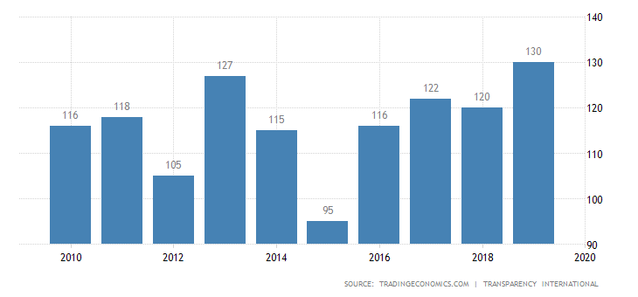
- Picture. source: https://tradingeconomics.com/mali/corruption-rank)
The chart shows that in 2019 Mali reached their all-time high point of corruption, though their average statistics from 2010 to 2019 is not of a great promise.
Besides the economic failure and corruption of the country, there are different food programmes that have a goal to ease the food crisis in Mali too. It is not by chance that malnutrition is also a huge problem for the civilians if we take the previous statistics into consideration. As the WFP points out recently, in 2020, poverty strikes nearly half of the population (44.9%), 34% of infant death is in relation to under-nutrition, land degradation and harvest-losses are all in connection with the widespread food crisis. In 2018, Unicef also highlights the next data: „This year, 1.6 million children are expected to suffer from severe acute malnutrition, which is a 50 percent increase from 2012, the Sahel’s last major nutrition crisis.”
As these were not enough, different insurgent and terrorist groups tries to grab power and set a foothold in the country, terrorizing the civilian population and causes losses to the peacekeeper European Nations too. The attacks against France, the soldiers of EUTM Mali mission, the MINUSMA by the jihadists are not new. As I have already written above, the Europeans started their work as peacekeepers and trainers in 2012 and 2013, and in 2016 there was an attack against peacekeepers where one soldiers died and four other injured. The France Diplomatie made a statement about the attack and it appeared on the Global Conflict Tracker too. However, this was only the beginning. 2016 was a rather violent year as there were several other attacks too. There was one terrorist attack in Gao against civilians and one attack against the camp MINUSMA in October in the Aguelhok. Of course, this list cannot be complete as numerous of these conflicts and fights did not get on the surface. The conflict continued in 2018 too and one can read about the ongoing conflict in 2019 and in 2020 as well. However, some of the best sources better to be read in French. In 2018, the jihadists targeted Touareg civilians. At that year, the French army intervened more then one occasion in the country in order to decrease the influence of the jihadist groups.
When I did my duty in the EUTM Mali in 2018, we faced a problem even more serious then the „normal” jihadist attacks. We were aware of the insurgent jihadists and the ongoing conflict between the Dogon and Fulani ethnicities. However, we were not ready to face a conflict between the FAMA forces and the civilians. The „mass graves” had such a huge impact on the whole region and the EUTM that the commanders immediately started a Human Rights project for the FAMA forces. I have a first-hand experience from this because I was part of the advisor team, the team of two lawyers and two soldiers, who did this Human Rights project to the FAMA. Our task was to help the lawyers to bring some „military” perpective into their presentation, to let the average soldiers be aware of the consequances of their actions. These mass graves were found around Mopti, in the central region of the country, where allegedly FAMA forces killed dozens of civilians around the villages, stating that they had been terrorists. At that time, this was one of the biggest concerns of the EU.
The year of 2019 did not bring a ceasefire as the attack continued. As AP wrote, there was an attack in Bamako against the EUTM in February, though no soldier was injured. The GlobalSecurity website highlighted the seriousness of the above-mentioned Dogon-Fulani conflict which reached its height in 2019. According to them there were at least 488 deaths among the Dogon and Fulani ethnicities from 2018 to 2019. This is also an ongoing problem that these two ethnicities tries to gain control of natural resources. The Dogon farmers and Fulani herders have a century-old conflict between each other over the land and the water. However, they do not try to make an agreement as they try to solve their conflict through war and weapons. This problem is becoming more serious as the climate is on the change and there are more and more droughts too. Nothing seems to change in 2020 too, as there was an IED attack against the EUTM near the area of Gao.
All of these gathered reports, studies, articles and personal experience give us the impression that there are so many levels and layers of these problems that it seems nearly impossible to ever have a solution for all of them. That whole region is rather „new” to democracy, they have to go through a nearly same route as we did in Europe. This is not going to be easy, but as one can observe, several programmes and organizations, as I mentioned them above, tries to help the to show the right way out of the tunnel.

The EUTM Mali and the Hungarian participation

The last time Mali got a scientific focus from the field of the defence forces and security issues was in 2014, when two articles,were written on the topic of the EUTM Mali and the Hungarians who serve there. Nevertheless, other international studies appeared in 2014 that focused on the EUTM too. Though after these years, one could only get to know the up-to-date information mainly through the press. The whole EUTM started in 2012 and 2013 when Diancounda Traoré asked help from the UN to help in the stabilization of the country after several rebellions and power take-overs from groups in connection to the al-Qaeda, for example the MNLA. Although, the al-Qaeda was and is there in Mali, there is a deep scar between the Fulani and Dogon ethnicities and the returning Tourages also created several conflict zones, as this topic was covered by Márton VARGA in his article. After these years, there was a huge change in our numbers in the EUTM MALI and also, the problems were not ceased to exist. Even the Hungarian press released an article on the topic of the increasing position of the Hungarians in the EUTM.
Since then, the starting years of the mission and focus of the scientific researches around 2013 and 2014, the numbers of our soldiers rose significantly in the EUTM. Up until 2017, two Hungarian sniper instructors served in the EUTM Mali. However, as one can read in Lt. Col. BESENYŐ’s article, at the beginning, there were some medical staff from Hungary too, but that was a short lived role for the Hungarians. According to one of the instructors who served between 2017 October and 2018 April, based on a personal interview, the general security situation was already bad, the country was ravaged by several problems. There was a huge need of the mobile training teams and the military instructors. These mobile traning teams, or as it was and is called CMATTs, did a traning for FAMA soldiers in different cities. My colleagues trained snipers in the city of Sikasso that is situated in the very southern part of the country. After 2018 April, me and my colleagues did the duty there, however, our numbers were risen from two to six and our role was changed too. According to the EU and the leadership of Mali, there was an extensive urge to train „normal” infantrymen thus we got the role of basic infantry instructors. As far as we served in the EUTM, we had to do five training sessions. One was based near our camp in Koulikoro, one was for the airport military personnel near Bamako, one in Segou and our last one was in Kayes. The soldiers who served after our duty started their half-year session with a CMATT in Timbuktu. Their numbers were raised from this six person to even more at the year of 2019. This six-soldiers participation was enlarged to nineteen and now, the number of Hungarian soldiers reach the number of twenty. This information was the on-the-spot data of the Hungarian soldiers. If we calculate, it means that from 2017 to 2020, the numbers were risen from two sniper instructors to six infantry instructors and then to the outstanding number of twenty infantry instructors and force protection personnel. The increasement of our numbers was also supported and announced by our Minister of Foreign Affairs, Péter Szijjártó in 2019, which means that there is a highlight now towards the happenings in Mali from the Hungarian press and public opinion too.
On the map below, I pinpointed the above mentioned locations of the mobile training teams (CMATT’s) with a red dot.
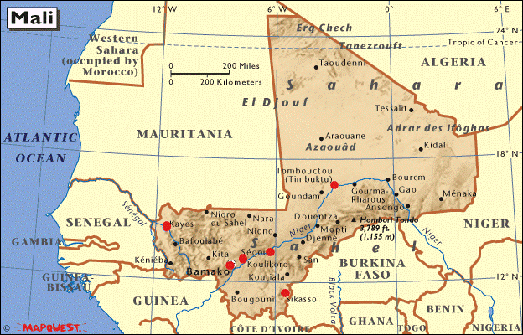
- Picture. Source: www.mapquest.com, the original map was edited by the author)
As one can observe, the trainings took place mostly in the southern and central regions. The uppest city where a CMATT happened was in Timbuktu, though these parts of the country were and are stricken by the terrorists and supervised mostly by the French. Briefly, in these 2 years, numerous trainings were give to the FAMA soldiers, with more of less success. Nevertheless, even a Train-the-trainer project started. That means it is not the goal of the EU to make a neverending training for the soldiers, but to train a number of capable NCO’s and Officers in order to pass the knowledge and experience and make the FAMA to be able to train themselves in the future.
In my opinion, this would be the ideal case and scenario, to let them train their own army and not to let the EU to do all the work instead of the FAMA. In the long run, they should deal with the region’s security with their own, instructed and capable forces. Though to obtain this level, the EUTM should continue their work to train the infantrymen and the trainers, but there is a huge progress and it seems that there is a hope to one day, the FAMA will bring peace to their country. Interestingly, there is also case studies that would like to deal with the Malian crises, that implies, that the security of the region has global importance, .

The personal experience of the soldiers who served in the EUTM Mali about the on-going problems and conflicts
All these data was gathered and processed personally through face-to-face interviews and through a questionnaire made by the author. The stating year is 2017 one shift before our duty time, when only two Hungarian soldiers served in the EUTM Mali as sniper instructors. According to one of the instructors, they did not have any cinflicts and problems with the jihadists, however, they heard from the previous shift that they had an attack on the EUTM personnel in Bamako when they had been visited a hotel. As far as my colleagues were concerned they only had to deal with the instruction of the snipers, the overall situation was not worse then the overall average. After we had the handover-takeover, our duty started to trainings. Around the summer monthes, we started to get to know about the already mentioned „mass-graves” and we heard the news of the continuous conflicts between the Dogon and Fulani too. There were also news from the northern regions, around the city of Gao where the FAMA forces had hard fights against the jihadists.
The main change in the camps security and the overall security situation of the EUTM got worse after our duty went home and the”new” shift arrived. That was still in 2018 but nearly the end of the year. At that time, there was an attack against the EUTM Camp located in Koulikoro. No European soldier got injured though, but there was an overall increasment of awareness from that point. The given shift also visited Timbuktu for a CMATT where they had hard time because of the harsh weather conditions, but there was no attack against the EUTM personnel. However, as we can observe from the above-mentioned articles and reports, there were continuous attacks against the French soldiers and the MINUSMA. The EUTM was aware of that naturally and raised their level of security too. In the year of 2019, there were rumors among the soldiers that the French would withdraw some of their forces from the north, but these were not true as Operation Barkhane is still the largest French military operation outside of France and they still fight against the jihadist forces. The shift that serves from 2019 to 2020 shared that same type of information with me in regard of the conflicts. As far as they are concerned, the forces of EUTM is respected by the locals and their work is uninterrupted. However, IED devices still means a common threat. From the perspective of the local ethnicities, the Dogon-Fulani conflict, it is still alive and continues to increase the death toll. Around the region of Mopti, there are atrocities against the forces of FAMA and the the region where the Operation Barkhane works there are the same type of conflicts occur. According to the our soldiers who serve now, the Barkhane forces still try to pacify the area, though their presence gives birth to more conflicts then it can solve. On the following map, I made a signal with a red circle around the areas where there were and are conflicts, based on the experience of the Hungarian soldiers.
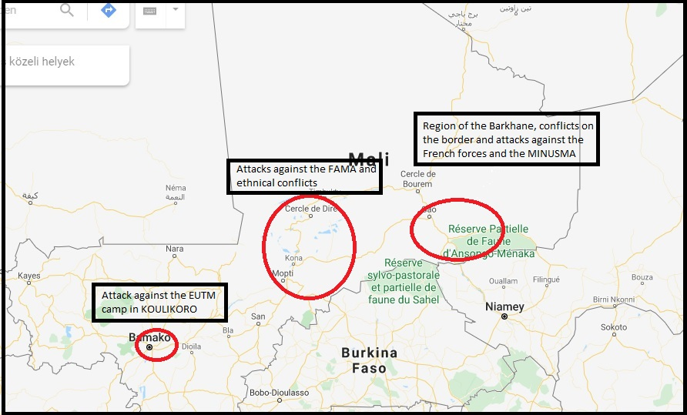
- Picture. Source: https://www.google.hu/maps, original map is edited by the author based on my gathered data)
From the viewpoint of the Hungarian soldiers, who did their from 2017 and 2019 we can assess that there is no change at all in the security situation. When the two sniper instructors handed over their shift to us, we still had to face the same problems and the same areas were stricken by the problems. The northern regions are still a source of conflict among the EU forces and the jihadists, while the central region hosts the never-ending resource-war between the Dogon and Fulani tribes. The „mass graves” that we had to deal with in 2018 ceased to exist now, as far as we are concerned, but there is no assurance that it will never happen again in the future. My hope is that the Human Rights project that we started worked and the FAMA forces are now more aware of their decisions and actions in order to not let these atrocities happen again.
Summary
It is not by chance that the readers and those have experience in the region, have dichotomous feelings on this topic. How it comes, that there are some many joint programmes from Europe which would like to help in the stabilization of the country? The MINUSMA, the EUTM Mali, the WFP, the IMF and so on and so forth, while they still rank among the top of the most corrupted countries, they still have ethnic wars, there are still jihadist attack against the French and even numerous civilians have been killed in the near past. It is nearly impossible to have a full understanding of all the problems as our culture, history values and indetity is totally different from those who live there. However, one can also observe several efforts that have already brought some changes and put Mali on the track towards a functioning state and society. One must understand that this is not a fast and easy procedure, not in a country that has so many scars from the colonial times and gained their independence not so long ago. Though it is worth consideration that what can be done by the Malian, the average civilians, statemen and leaders in order to move their own country forward, towards peace and growth. The work of the French army, the EUTM and MINUSMA should not cease to exist from today to tomorrow, the EU should continue their work and with one step forward at a time and with a joint effort one day there may be peace in Mali too. For this, first, a stable state of economy should be achieved, a lawful democracy with much lower corruption. As these factors will be given, the state and their army would be able to mediate peace between the Fulani and Dogon, as with a stable economy, the current food and resource crisis can be eased. After these conflicts will be done, the state will be able to target the ever-turmoiling northern regions near Gao in order to strike down the jihadists. However, everyone knows that this would be the best and most ideal scenario, but the reality may not be the same track.

Bibliography
- AP. EU training mission comes under atttack in Mali. https://apnews.com/c375c2a0628b43d286c71ef06f5fb89f (downloaded: 04 March 2020)
- EUTM Mali. Train the trainers. https://www.eutmmali.eu/train-the-trainers (accessed: 03 March 2020)
- Facebook. Irish Defence Forces. https://www.facebook.com/notes/óglaigh-na-héireann-irish-defence-forces/defence-forces-personnel-involved-in-incident-in-mali/31086565025119 (downloaded: 04 March 2020)

Fergus KELLY: France and Sahel partner forces conduct ‘unprecedented’ operation in Burkina Faso and Mali https://thedefensepost.com/2019/11/18/joint-operation-burkina-faso-mali-barkhane-bourgou-iv-sahel/ 2019. 11. 18. (accessed: 05 March 2020)
- France Diplomatie. https://www.diplomatie.gouv.fr/en/country-files/mali/news/article/mali-attack-against-the-european-union-s-training-and-advisory-mission-for-the (downloaded: 04 March 2020)
- France Diplomatie. https://www.diplomatie.gouv.fr/fr/dossiers-pays/mali/evenements/article/mali-attaques-a-Gao-31-06-16 (accessed: 03 March 2020)
- France Diplomatie. https://www.diplomatie.gouv.fr/fr/dossiers-pays/mali/evenements/article/mali-attaque-contre-la-minusma-23-01-17 (accessed: 05 March 2020)
- Francesca BASTAGLI, Camilla TOULMIN: Mali: Economic factors behind the crisis. European Parliament, Directorate General of External Policies. 2014. https://www.europarl.europa.eu/RegData/etudes/etudes/join/2014/433754/EXPO-DEVE_ET(2014)433754_EN.pdf ISBN: 978-92-823-5280-9. (downloaded: 05 March 2020)
- Francesca BASTAGLI, Camilla TOURMIN: Economic factors behind the crisis. https://www.odi.org/publications/8318-mali-economic-factors-behind-crisis (downloaded: 05 March 2020)
- Global Conflict Tracker https://www.cfr.org/interactive/global-conflict-tracker/conflict/destabilization-mali
- Global Security. Fulani-Dogon Conflict. https://www.globalsecurity.org/military/world/war/fulani-dogon.htm (downloaded: 04 March 2020)

https://www.lemonde.fr/afrique/article/2019/05/04/barkhane-l-ensablement-en-terre-oubliee_5458125_3212.html (accessed: 05 March 2020)
- IMF. https://www.imf.org/en/News/Articles/2019/09/03/NA090319-mali-supporting-growth-in-the-face-of-security-challenges (downloaded: 05 March 2020)
- Independent Mali. https://www.britannica.com/place/Mali/Independent-Mali (downloaded: 05 March 2020)
- Ingo PETERS, Enver FERHATOVIC, Rabea HEINEMANN, Susan BERGER and Sofia Marie STURM: European Union’s Crisis Response in the Extended Neighbourhood: Comparing the EU’s Output Effectiveness in the Cases of Afghanistan, Iraq and Mali. EUNPACK. 2018. 03. 10. http://www.eunpack.eu/sites/default/files/publications/WP%207%20Comparative%20for%207.1._final%20version%2010.03.18.pdf (downloaded: 05 March 2020)
- Jan-Uwe PETTKE: European Union Training Mission Mali (EUTM Mali) as an example of the European Union’s Comprehensive Approach to Crisis Management. In: Europa-Kolleg Hambur, Institue for European Integration, Study Paper 03/14. https://www.europa-kolleg-hamburg.de
- Le Monde. Au Mali, des dizaines de civils touareg tués par des djihadistes présumés. https://www.lemonde.fr/afrique/article/2018/12/13/au-mali-des-dizaines-de-civils-touareg-tues-par-des-djihadistes-presumes_5396976_3212.html (downloded: 04 March 2020)
- Le Monde. Au Mali, intervention de la force « Barkhane » lors de combats entre l’armée et des djihadistes. https://www.lemonde.fr/afrique/article/2018/10/18/au-mali-intervention-de-la-force-barkhane-lors-de-combats-entre-l-armee-et-des-djihadistes_5371408_3212.htm (downloaded: 04 March 2020)
- LT.Col. János BESENYŐ: Hungarian soldiers in EUTM Mali. In: Tradecraft Review, . 2014/2 Special Issue. p. 5-18, HU ISSN 2063-2908
- LT.Col. János BESENYSŐ: Hungarian soldiers in EUTM Mali. In: Tradecraft Review, 2014/2 Special Issue. p. 5-18, HU ISSN 2063-2908
- Mali corruption report. https://www.ganintegrity.com/portal/country-profiles/mali/ (downloaded: 05 March 2020)
- Mariann VECSEY: The EUTM Mali and the role of hungary in the mission. In: Tradecraft Review, . 2014/2 Special Issue. p. 112-122, HU ISSN 2063-2908

Márton VARGA: A tuaregek – lázadástól a polgárháborúig. In: Hadtudományi szemle.2019. 12. vol. 2. pp. 63-78 HU ISSN 2060-0437

Morgane LE CAM: Au Mali, l’opération « Barkhane » ensablée en terre oubliée
- Morten BØÅS, Abdoul Wahab CISSÉ, Aboubacar DIALLO, Bård DRANGE, Frida KVAMME and Eva STAMBØL: The EU, security sector reform and border management in Mali. EUNPACK. 2018. 01. 31. http://www.eunpack.eu/sites/default/files/publications/2018-01-31%20D7.4%20Working%20paper%20on%20implementation%20of%20EU%20crisis%20response%20in%20Mali.pdf (dowloaded: 03 March 2020)
- MTI/honvedelem.hu: Szijjártó Péter: Magyarország megduplázza a Maliban és a Száhel-övezetben szolgáló katonáinak számát. https://honvedelem.hu/cikk/szijjarto-peter-magyarorszag-megduplazza-a-maliban-es-a-szahel-ovezetben-szolgalo-katonainak-szamat/ (downloaded: 04 March 2020)
- MTI: Mali sürgős segítséget kért az ENSZ-től. https://index.hu/kulfold/2013/01/11/mali_surgos_segitseget_kert_az_ensz-tol/ (downloaded: 04 March 2020)
- Reuters. Mali says some soldiers implicated after mass graves found. https://www.reuters.com/article/us-mali-security/mali-says-some-soldiers-implicated-after-mass-graves-found-idUSKBN1JF22K (downloaded: 04 March 2020)
- Tiemoko DIALLO, David LEWIS: Mali rebels push south to open third front-sources. https://www.reuters.com/article/uk-mali-fighting/mali-rebels-push-south-to-open-third-front-idUKTRE80P1WT20120126 (downloaded: 04 March 2020)
- Unicef. Nutrition Crisis in Mali. https://www.unicef.org/wca/stories/nutrition-crisis-mali (downloaded: 05 March 2020)
- World Food Programme. https://www.wfp.org/countries/mali (downloaded: 05 March 2020)

Global Conflict Tracker https://www.cfr.org/interactive/global-conflict-tracker/conflict/destabilization-mali
MINUSMA - United Nations Multidimensional Integrated Stabilization Mission in Mali
Independent Mali. https://www.britannica.com/place/Mali/Independent-Mali (downloaded: 05 March 2020)
Francesca Bastagli, Camilla Tourmin: Economic factors behind the crisis. https://www.odi.org/publications/8318-mali-economic-factors-behind-crisis (downloaded: 05 March 2020)
IMF – International Monetary Fund – Nemzetközi Valutaalap
IMF. https://www.imf.org/en/News/Articles/2019/09/03/NA090319-mali-supporting-growth-in-the-face-of-security-challenges (downloaded: 05 March 2020)
Francesca BASTAGLI, Camilla TOULMIN: Mali: Economic factors behind the crisis. European Parliament, Directorate General of External Policies. 2014. https://www.europarl.europa.eu/RegData/etudes/etudes/join/2014/433754/EXPO-DEVE_ET(2014)433754_EN.pdf ISBN: 978-92-823-5280-9. (downloaded: 05 March 2020)
Mali corruption report. https://www.ganintegrity.com/portal/country-profiles/mali/ (downloaded: 05 March 2020)
WFP – World Food Programme – ENSZ Világélelmezési Programja
World Food Programme. https://www.wfp.org/countries/mali (downloaded: 05 March 2020)
Unicef. Nutrition Crisis in Mali. https://www.unicef.org/wca/stories/nutrition-crisis-mali (downloaded: 05 March 2020)
France Diplomatie. https://www.diplomatie.gouv.fr/en/country-files/mali/news/article/mali-attack-against-the-european-union-s-training-and-advisory-mission-for-the (downloaded: 04 March 2020)
https://www.cfr.org/interactive/global-conflict-tracker/conflict/destabilization-mali (accessed: 05 March 2020)
France Diplomatie. https://www.diplomatie.gouv.fr/fr/dossiers-pays/mali/evenements/article/mali-attaques-a-Gao-31-06-16 (accessed: 03 March 2020)
France Diplomatie. https://www.diplomatie.gouv.fr/fr/dossiers-pays/mali/evenements/article/mali-attaque-contre-la-minusma-23-01-17 (accessed: 05 March 2020)
Le Monde. Au Mali, des dizaines de civils touareg tués par des djihadistes présumés. https://www.lemonde.fr/afrique/article/2018/12/13/au-mali-des-dizaines-de-civils-touareg-tues-par-des-djihadistes-presumes_5396976_3212.html (downloded: 04 March 2020)
Le Monde. Au Mali, intervention de la force « Barkhane » lors de combats entre l’armée et des djihadistes. https://www.lemonde.fr/afrique/article/2018/10/18/au-mali-intervention-de-la-force-barkhane-lors-de-combats-entre-l-armee-et-des-djihadistes_5371408_3212.htm (downloaded: 04 March 2020)
FAMA – Forces Armées Malienne – Mali hadereje
Reuters. Mali says some soldiers implicated after mass graves found. https://www.reuters.com/article/us-mali-security/mali-says-some-soldiers-implicated-after-mass-graves-found-idUSKBN1JF22K (downloaded: 04 March 2020)
AP. EU training mission comes under atttack in Mali. https://apnews.com/c375c2a0628b43d286c71ef06f5fb89f (downloaded: 04 March 2020)
Global Security. Fulani-Dogon Conflict. https://www.globalsecurity.org/military/world/war/fulani-dogon.htm (downloaded: 04 March 2020)
IED – Improvised Explosive Device – Rögtönzött robbanóeszköz
https://www.facebook.com/notes/óglaigh-na-héireann-irish-defence-forces/defence-forces-personnel-involved-in-incident-in-mali/31086565025119 (downloaded: 04 March 2020)
Mariann VECSEY: The EUTM Mali and the role of hungary in the mission. In: Tradecraft Review, . 2014/2 Special Issue. p. 112-122, HU ISSN 2063-2908
LT.Col. János BESENYSŐ: Hungarian soldiers in EUTM Mali. In: Tradecraft Review, 2014/2 Special Issue. p. 5-18, HU ISSN 2063-2908
Jan-Uwe PETTKE: European Union Training Mission Mali (EUTM Mali) as an example of the European Union’s Comprehensive Approach to Crisis Management. In: Europa-Kolleg Hambur, Institue for European Integration, Study Paper 03/14. https://www.europa-kolleg-hamburg.de
Tiemoko DIALLO, David LEWIS: Mali rebels push south to open third front-sources. https://www.reuters.com/article/uk-mali-fighting/mali-rebels-push-south-to-open-third-front-idUKTRE80P1WT20120126 (downloaded: 04 March 2020)
Márton VARGA: A tuaregek – lázadástól a polgárháborúig. In: Hadtudományi szemle.2019. 12. vol. 2. pp. 63-78 HU ISSN 2060-0437
MTI: Mali sürgős segítséget kért az ENSZ-től. https://index.hu/kulfold/2013/01/11/mali_surgos_segitseget_kert_az_ensz-tol/ (downloaded: 04 March 2020)
LT.Col. János BESENYŐ: Hungarian soldiers in EUTM Mali. In: Tradecraft Review, . 2014/2 Special Issue. p. 5-18, HU ISSN 2063-2908
CMATT – Combined Mobile Advisory and Training Team
MTI/honvedelem.hu: Szijjártó Péter: Magyarország megduplázza a Maliban és a Száhel-övezetben szolgáló katonáinak számát. https://honvedelem.hu/cikk/szijjarto-peter-magyarorszag-megduplazza-a-maliban-es-a-szahel-ovezetben-szolgalo-katonainak-szamat/ (downloaded: 04 March 2020)
EUTM Mali. Train the trainers. https://www.eutmmali.eu/train-the-trainers (accessed: 03 March 2020)
Morten BØÅS, Abdoul Wahab CISSÉ, Aboubacar DIALLO, Bård DRANGE, Frida KVAMME and Eva STAMBØL: The EU, security sector reform and border management in Mali. EUNPACK. 2018. 01. 31. http://www.eunpack.eu/sites/default/files/publications/2018-01-31%20D7.4%20Working%20paper%20on%20implementation%20of%20EU%20crisis%20response%20in%20Mali.pdf (dowloaded: 03 March 2020)
Ingo PETERS, Enver FERHATOVIC, Rabea HEINEMANN, Susan BERGER and Sofia Marie STURM: European Union’s Crisis Response in the Extended Neighbourhood: Comparing the EU’s Output Effectiveness in the Cases of Afghanistan, Iraq and Mali. EUNPACK. 2018. 03. 10. http://www.eunpack.eu/sites/default/files/publications/WP%207%20Comparative%20for%207.1._final%20version%2010.03.18.pdf (downloaded: 05 March 2020)
Morgane LE CAM: Au Mali, l’opération « Barkhane » ensablée en terre oubliée https://www.lemonde.fr/afrique/article/2019/05/04/barkhane-l-ensablement-en-terre-oubliee_5458125_3212.html (accessed: 05 March 2020)
Fergus KELLY: France and Sahel partner forces conduct ‘unprecedented’ operation in Burkina Faso and Mali https://thedefensepost.com/2019/11/18/joint-operation-burkina-faso-mali-barkhane-bourgou-iv-sahel/ 2019. 11. 18. (accessed: 05 March 2020)

